**The Giraffe That Doesn’t Look Like a Giraffe**

by

Darren Bigelow

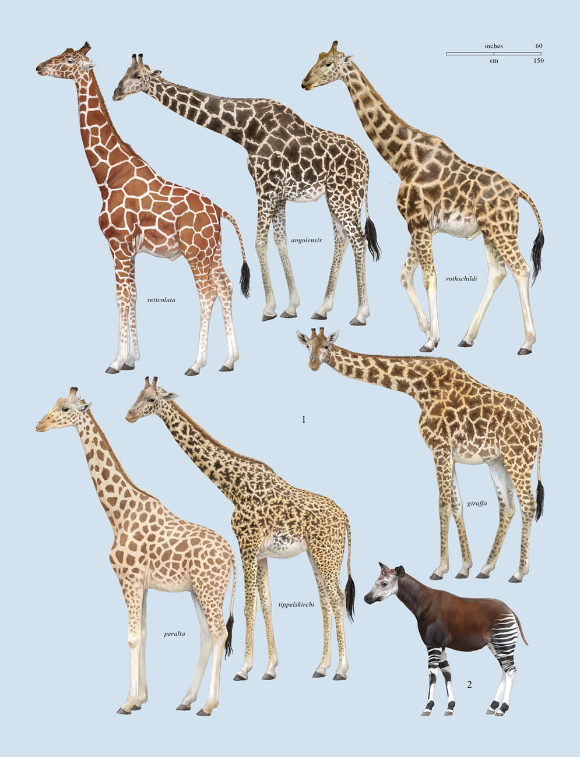

Elephants are grey, grizzly bears are brown and chameleons can be just about any color they please. Now there is an animal that has black-and-white stripes just like a zebra, but it’s not a zebra. Quite large, with a dark-brown (and sometimes reddish) back, this animal has long ears, kind of long legs and a snake-like purple tongue. It’s in the giraffe family, so you probably think its neck is quite long, right? Wrong. Its neck is much shorter that a giraffe’s neck, so this animal really doesn’t look much like a giraffe.

Have you guessed what this mysterious creature is? It’s called an Okapi (oh-COP-ee). Okapis are popular in zoos around the world. In the wild, okapis can be found in central Africa.

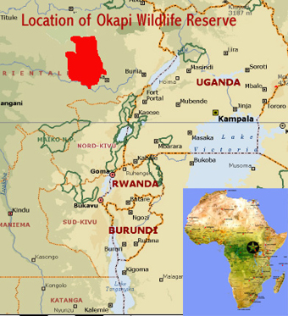

They like to live in thick tropical jungles that have lots of trees and bushes. The jungles are hot, so the plants provide the okapis with plenty of cool shade and water. They share their home with chimpanzees, forest elephants, red river hogs and little people called the Aka Yaka.

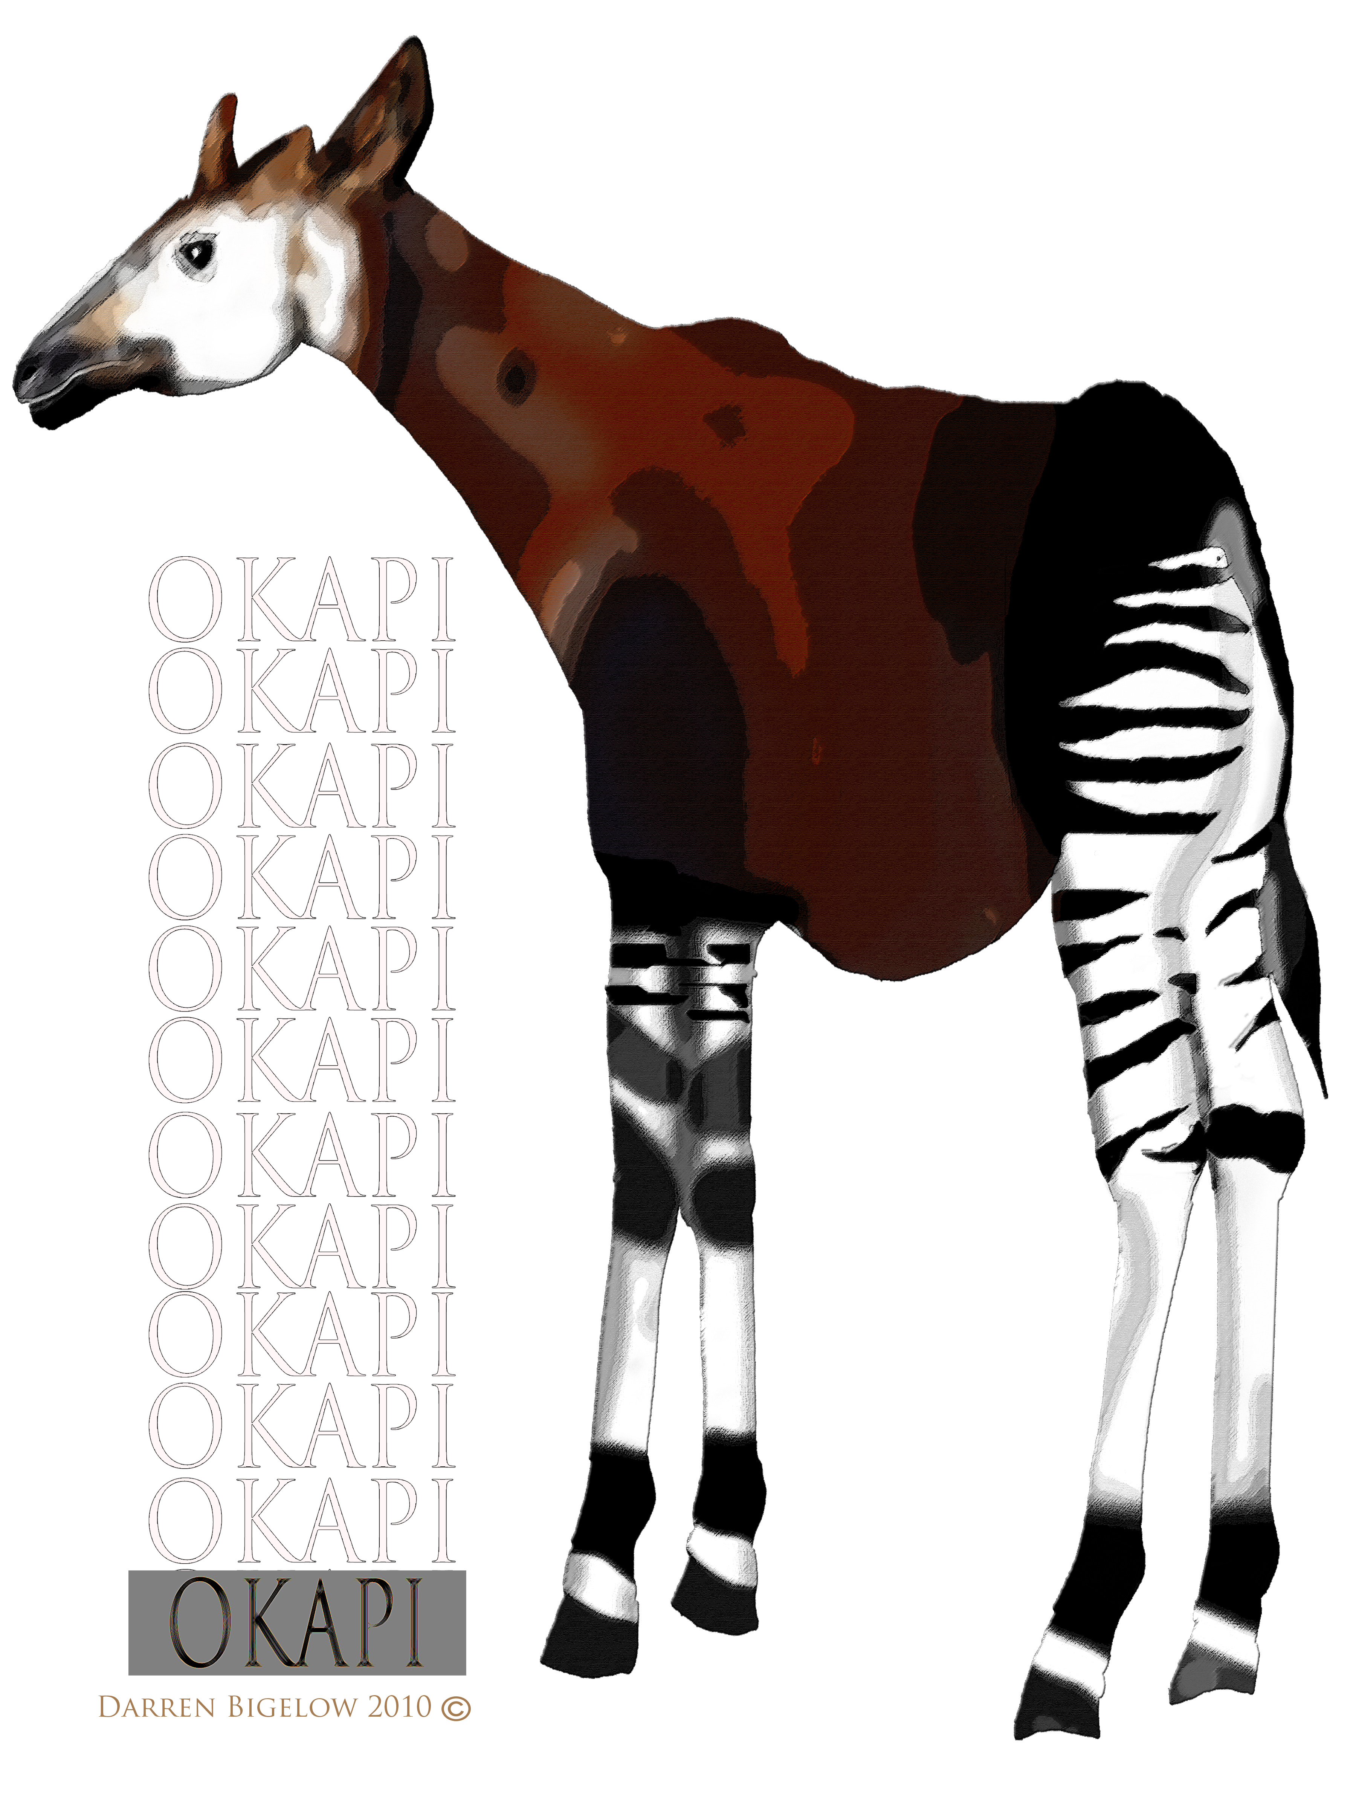

The Aka Yaka had known for hundreds of years about the okapi. However, the rest of the world only became aware of them around the year 19001. The jungle is probably the reason why—it’s a great place to not be found. Have you ever played a game of hide and seek? It’s fun, isn’t it? Well, when okapis hide, they aren’t playing a game. They’re trying to stay alive.

The jungle is full of predators like leopards that want to eat them. The okapis’ coloration acts like camouflage. That means its colors and patterns (like its stripes) help it to blend into the jungle. The dark back and swirly stripes might look like a tree trunk and leaves to a leopard.

Some scientists believe that besides camouflage, the okapi’s markings also help keep a baby okapi from getting separated from its mother. By keeping its eyes on the stripes of the mother’s legs, the baby follows its mother through the jungle. That way it won’t get lost.

Okapis are herbivores, eating only plants and not meat. The jungle is like a big salad to them. Wouldn’t it be great if you could live in a house surrounded by hamburgers and pizza? Okapis use their long purple tongues, which are up to 18 inches long, when they eat. Their tongue wraps around small branches and strips the leaves off.

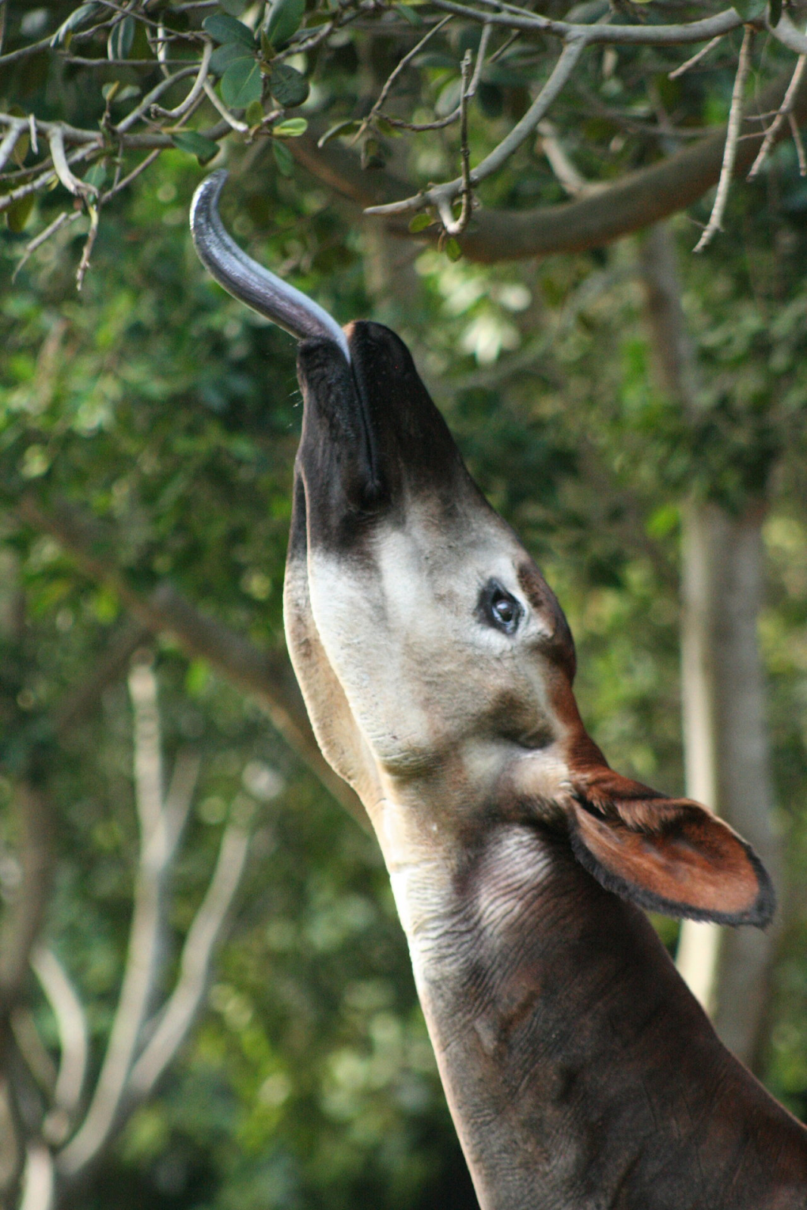

Okapis use their long tongues for other things as well. Can you stick your tongue in your nose? Okapis can. They can also use their tongues to clean their ears. That sounds kind of gross, doesn’t it? It’s not . . . it’s practical. Okapis have hooves for feet, just like cows, so they can’t wash their face the way you do—they don’t have hands, so their tongues are very useful.

Many okapis are left in the wild, numbering 20,000 or more. Unfortunately, these wonderful creatures are slowly losing their jungle home because of deforestation. Deforestation is when people cut down trees and bushes. Why do people do this? Well, sometimes the trees are used for wood to make houses, and other times the plants are taken out to make room for farms. These things are important, but hopefully the okapis won’t lose too much of their jungle home.

The End